NMIMS Online MBA program

NMIMS Online MBA

NMIMS Online MBA Course
The NMIMS (Narsee Monjee Institute of Management Studies) offers a globally recognized online MBA (Master of Business Administration) course under its Centre for Distance and Online Education department, abbreviated as NMIMS Online. It is a 2 year postgraduate degree program with a 100% online learning mode.

The NMIMS online MBA assists students in becoming industry-ready professionals with practical learning experience. The course delivery method includes guidance from renowned academicians and 24*7 access to live/recorded lectures. For better industry relevance, the course is offered in 5 different specializations spanning multiple disciplines with an in-depth emphasis on the core understanding of the sector.

The institute has 40+ years of excellence in multidisciplinary education, which makes its online MBA program an ideal choice to build a successful professional career. For a better learning experience, students are provided with e-books, journals, and lecture transcripts. With the assistance of renowned faculty, the NMIMS online MBA enhances the essential skills among students to provide a pathway to immense success.

NMIMS Online MBA Accreditations
NMIMS online MBA is globally recognized for its several accreditations from apex accredited institutions. Some of these are listed below:
- Accredited with an “A++” grade by the National Assessment and Accreditation Council (NAAC).
- Member of the Association of Indian Universities (AIU).
- Ranks #95 under the overall category, #52 under the university category, and #24 under the management category of the National Institutional Ranking Framework (NIRF).
- Accredited by the Bar Council of India (BCI).
- Accredited by the National Council for Teacher Education (NCTE).
- Entitled by the University Grants Commission (UGC).

NMIMS Online MBA Eligibility Criteria
The eligibility criteria for the NMIMS online MBA course are as follows:
- The interested candidate must have completed a bachelor’s degree with a 10+2+3 educational qualification from a recognized university.
- The applicant must have scored a minimum of 50% aggregate marks at the graduation level (45% for reserved category students, SC/ST/OBC/PwD).

NMIMS Online MBA Admission Process
To enroll in the NMIMS online MBA course, follow the below listed step-by-step admission process for a hassle-free enrollment procedure:
Step 1. Visit the official website of NMIMS Online and register.
Step 2. Complete the registration process to receive credentials to access the admission portal.
Step 3. Start filling out the application form with accurate information.
Step 4. Attach the supporting documents and submit the NMIMS online MBA application form.
Step 5. The university will verify the application form, documents, and fee.
Step 6. Once the verification is completed, the university will issue a “student number” and dispatch your study kit along with the activation of the student portal and LMS.

The NMIMS online MBA charges INR 1,200 /- as an admission processing fee.

NMIMS Online MBA Course Facts
- The NMIMS online MBA is a 2 year postgraduate degree program with 4 years of validity.
- For world-class exposure and education quality, the course provides 120+ IIT and IIM graduates as faculty members.
- Students can raise their queries via the ticketing tool under the NMIMS online student support.
- The course includes one-on-one personalized guidance through an expert coach for a strategic career roadmap.
- The NMIMS has a vast network of 82 K+ alumni across the world, with 8 K+ firms hiring their alumni.
- The NMIMS online MBA follows a KSA (Knowledge-Skill-Attitude) framework.

NMIMS Online MBA Specializations
The NMIMS online MBA is offered in 5 industry-centric specializations, which develop core competencies across different industries, depending on the student's preference. The specializations are as follows:
- Marketing Management
- Business Management
- Financial Management
- Human Resource Management
- Operations and Data Sciences Management

NMIMS Online MBA Specialization wise fees
Each online MBA specialization at NMIMS Online follows a similar fee structure of INR 55,000 /- per semester. The table below states the NMIMS online MBA specializations' semester-wise fee structure:
NMIMS Online MBA Specializations | NMIMS Online MBA Fee (per semester)
Marketing Management | INR 55,000 /-
Business Management | INR 55,000 /-
Financial Management | INR 55,000 /-
Human Resource Management | INR 55,000 /-
Operations and Data Sciences Management | INR 55,000 /-

NMIMS Online MBA Sample Certificate Photo
Post-completion of the NMIMS online MBA course, enrolled students are entitled to an online postgraduate degree in Master of Business Administration that is offered at par with a traditional on-campus MBA degree.
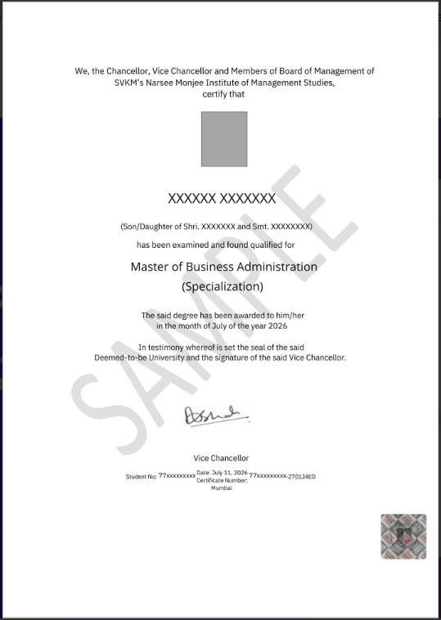

NMIMS Online MBA Fee Structure
The fee structure for the online MBA at NMIMS is cost-effective but follows different fee amounts in semester, annual, and lump sum plans. A brief breakdown of the fees is mentioned below:
Fee Plan | Fee Amount | Total Fee
Semester Plan | INR 55,000 /- (4 semester) | INR 2,20,000 /-
Annual Plan | INR 1,05,000 /- (2 years) | INR 2,10,000 /-
One-time payment plan | INR 1,96,000 /- | INR 1,96,000 /-

To assist students facing financial constraints, the university offers an easy EMI facility. The NMIMS online MBA no-cost EMI facility can be availed without owning a credit card, and it allows students to pay their course fee in affordable monthly instalments starting from INR 8,750 /-, ranging from 3 to 12 months. For financial aid, students can also opt for the scholarship facility.
The NMIMS online MBA EMI facility is offered through the following banks:
- HDFC Bank
- ICICI Bank
- Axis Bank
- Citi Bank
- Standard Chartered Bank
- HSBC Bank
- Kotak Mahindra Bank

NMIMS Online MBA Syllabus/Curriculum
The course syllabus is designed by industry experts and qualified professionals to offer insights into several essential key management concepts. The NMIMS online MBA syllabus follows a semester pattern, and for a better course understanding, the detailed syllabus of marketing specialization is listed below:
NMIMS Online MBA Syllabus/Subjects
Year I
Semester I | Semester II
- Business Communication  - Financial Accounting  - Micro Economics & Macro Economics  - Organisational Behaviour  - Marketing Management  - Quantitative Methods – I | - Cost & Management Accounting  - Human Resource Management  - Strategic Management  - Business Analytics  - Legal Aspect of Business  - Operations Management
Year II
Semester III | Semester IV
- Corporate Finance  - Research Methodology  - Project Pre-work  - Brand Management  - Consumer Behaviour  - Integrated Marketing Communications  - Sales Management | - Indian Ethos & Ethics  - Corporate Sustainability  - International Business  - Project  - International Marketing  - Services Marketing  - Digital Marketing

NMIMS Online MBA Placement Partners
To offer a promising professional career ahead for students enrolled in the NMIMS online MBA course, the university offers dedicated placement assistance with personalized career services. They have witnessed a 40% improvement in the profile ranking of enrolled students and provide 6 months of access to relevant opportunities via job portals like Updazz, IIMJobs, and Hirist.
The career services offered under the NMIMS online MBA placement assistance are:
- Job portal access.
- Career coaching.
- Practice interviews.
- Profile development (CV guidance, LinkedIn optimization, etc).
These career services also provide AI-powered personalized recommendations to boost your profile based on company insights. The university has 500+ hiring partners with 20000+ recruiters shaping students’ careers. Some of the leading hiring partners include:
- ICICI Securities
- Oracle
- WIPRO BPO
- Goldman Sachs
- Tesco
- Mercedes Benz

NMIMS Online MBA Job Roles & Salary
Students who graduate from the NMIMS online MBA are capable of acquiring a well-paying job role in their preferred field with the skills and abilities developed throughout the course duration. The table below lists the job profiles offered to an NMIMS online MBA graduate along with their average salary.
Job Prospects | Average Salary
Business Analyst | INR 8.5 LPA
Marketing Manager | INR 10 LPA
Human Resource Manager | INR 7.5 LPA
Social Media Manager | INR 6 LPA
Financial Analyst | INR 11 LPA

NMIMS Online MBA FAQs
- Is NMIMS online good for an MBA?
- The top-notch academic quality with world-class student support services, NMIMS online is an ideal and good choice for an MBA.
- What is the cost of an NMIMS online MBA?
- The NMIMS online MBA costs INR 1,96,000 /- for the entire 2 year course if the enrolled student opts for a one-time payment plan.
- What is the average package for the NMIMS distance MBA?
- The average package for the NMIMS distance MBA varies between INR 4 & INR 7 LPA.
- Is an NMIMS online degree valid?
- Yes, the University Grants Commission (UGC) has recognized the NMIMS online degree program, which makes it equivalent to regular degree courses.
- Which is better, symbiosis or NMIMS for an online MBA?
- Both universities are globally recognized and offer valid degree courses. However, symbiosis is more renowned with several international rankings, making it a better option to consider.

NMIMS Online MBA Reviews
- The best thing I liked about the online MBA course at NMIMS was the extended course duration. Due to some issues, I dropped out for a year, but later on managed to complete my program within a span of 3 years.
- For me NMIMS online MBA was up to the mark and met all my expectations. However, there is a little scope for improvement, but overall, I had a good experience.
- I recently graduated from the NMIMS online MBA program, and it is a worthwhile option due to its minimal interaction with faculty and self paced learning facility.
- The online MBA course at Narsee Monjee also offers career services that I liked the most, and on behalf of it, I recommend it to others too.

